Do the settings



Time Tracker

**VW Installation Center Steps**

28th March 2013

DISCLAIMER

**© 2017 Ramco Systems Ltd. All rights reserved. All trademarks acknowledged.**

This document is published by **Ramco Systems Ltd**. without any warranty. No part of this document may be reproduced or transmitted in any form or by any means, electronic or mechanical, for any purpose without the written permission of **Ramco Systems Limited**.

Improvements and changes to this text necessitated by typographical errors, inaccuracies of current information or improvements to software programs and/or equipment, may be made by Ramco Systems Limited, at any time and without notice. Such changes will, however, be incorporated into new editions of this document. Any hard copies of this document are to be regarded as temporary reference copies only.

The documentation has been provided for the entire Aviation solution, although only a part of the entire solution may be deployed at the customer site, in accordance with the license agreement between the customer and Ramco Systems Limited. Therefore, the documentation made available to the customer may refer to features that are not present in the solution purchased / deployed at the customer site.

Table of Contents

Steps for Installation 4

Choice – Typical + Default + Multi server 5

Maintenance Installation 11

# Steps for Installation

The following screen will be popped up.

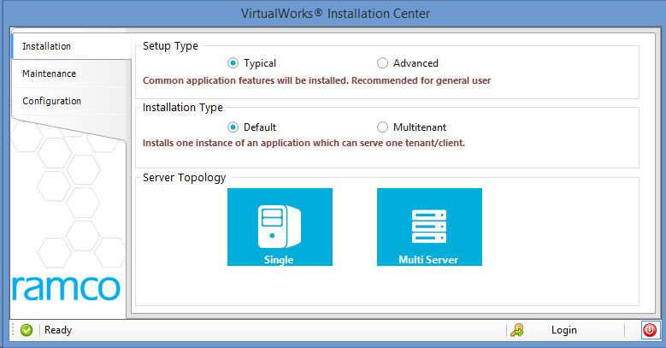

Choose Setup Type as TYPICAL for a quick installation with default parameters. TYPICAL will capture basic mandatory information needed for the installer to run.

Choose Advanced – For complex installation setup and it needs knowledge of architecture and topology of RVW application.

Choose Installation Type as Multitenant if you are setting up an environment for multiple customers (Public cloud kind of setup) else choose Default.

Choose Server Topology as Single if WEB, APP, DB layers are going to be installed in a single server. Choose Multi server otherwise.

# Choice – Typical + Default + Multi server

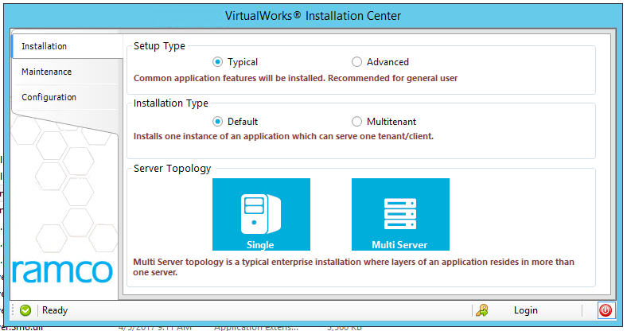

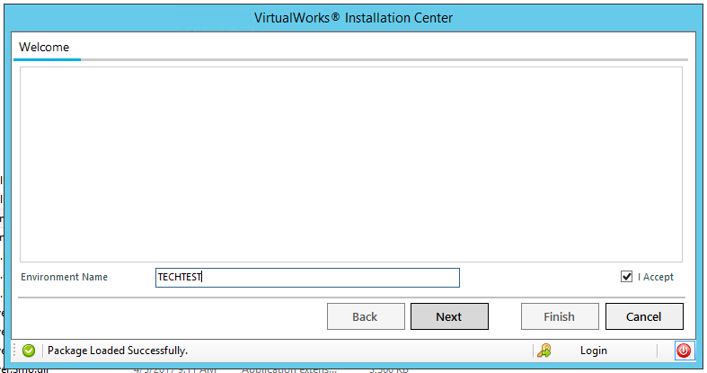

Give the environment name and click on NEXT

The following screen will be shown

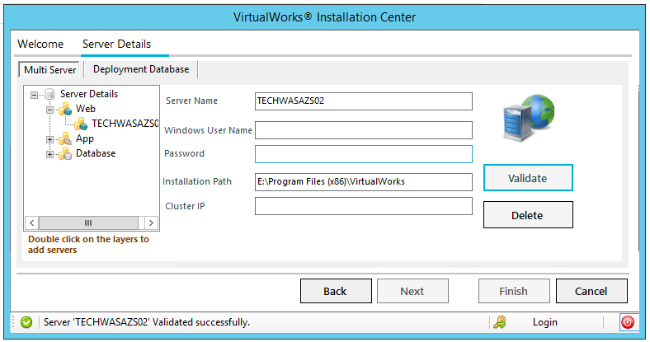

In the SERVERDETAILS tree on the left side, double click on the respective nodes to capture the server details. Provide the servername, windows username (which has administrator privileges), password and installation path. Click on VALIDATE.

ClusterIP – This is not mandatory. Needed only in a load balanced kind of environment setup.

Add Appserver details as similar to webserver and click on VALIDATE

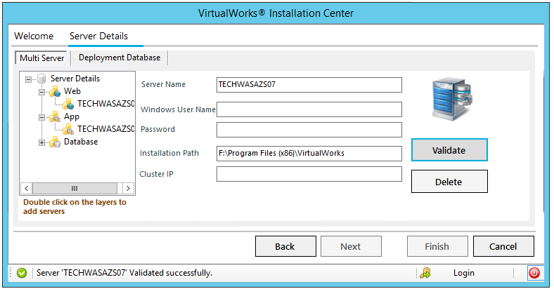

The following is for capturing Database server details

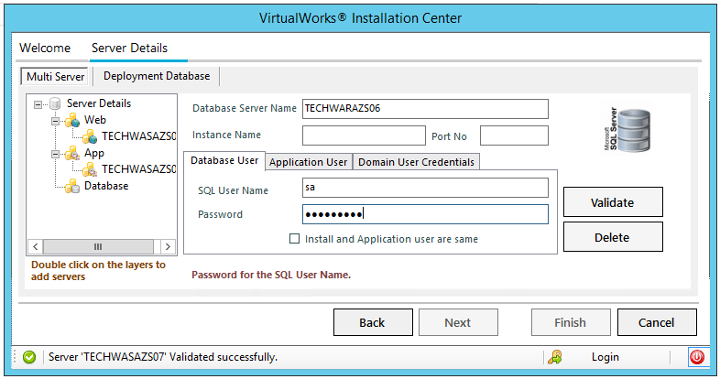

Database server Name – Mandatory – Provide the same

Instance Name (NON mandatory) - If the sql server installed in database server is having an Instance name, provide the same in Instance Name field.

PortNo (Non Mandatory) – If sql server is running on default port(1433), leave this field empty else provide the respective data.

In the tabbed control below.

Database User Tab

SQL Username(mandatory) – Sql user which has DBO privileges. This will be used to run the installation in SQL server.

Password (mandatory) – password for the above user.

Click on VALIDATE

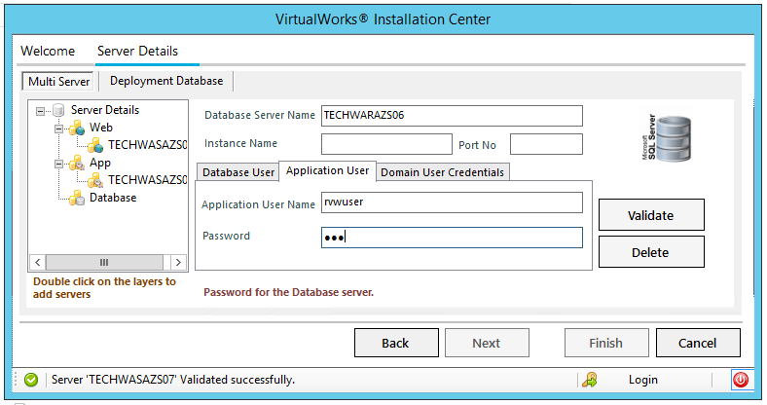

Application user tab

Application UserName (mandatory) – Sql user name which will be used to connect to DB layer by the application at runtime.

Password (mandatory) – password for the same.

Click on VALIDATE

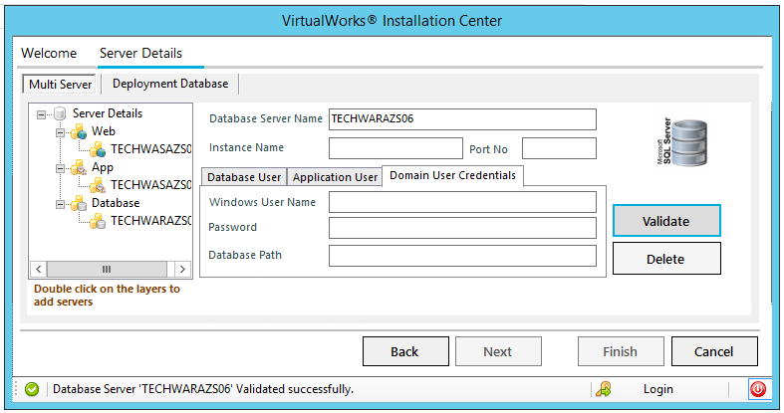

Domain User Credentials Tab

Windows Username (Non mandatory) – Please provide this only if you have to provide a different path for creating DEPDB. Windows username which has admin privileges should be provided.

Password – Password for the above user

Database Path – Path in which the database will get created. Click on VALIDATE

Then click on DEPLOYMENT Tab

All the data provided in the other tab will be defaulted here. So click on VALIDATE and then NEXT button will be enabled.

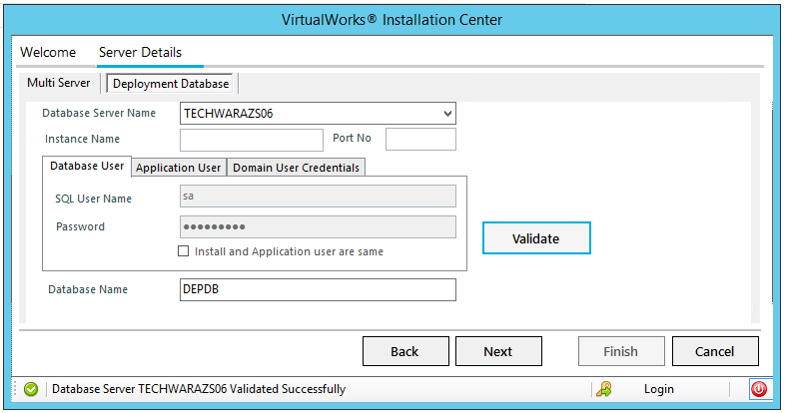

Click on NEXT and the summary page will be shown.

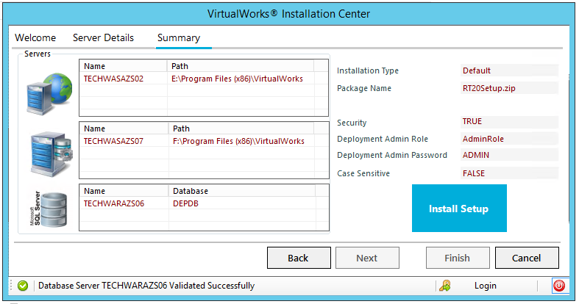

Click on Install Setup. Once the set-up is completed successfully, the following dash board will be launched. This will indicate the status of the installation in each of the layers. A green tick mark indicates successful installation.

RSSetup completed –Maintenance Mode

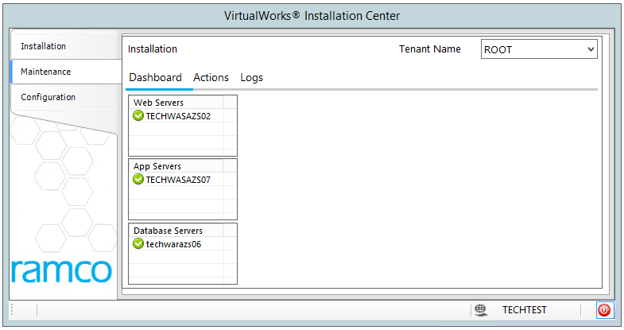

Now you can launch the browser and check if the installation is fine. Launch Ramco Web Application’s security pages and verify that installation is successful. (Visit http://YourWebServerName/RVW and you should get a login page. In case of any error, please contact Ramco Technical Support with a screenshot of the error. Please also send across contents of C:\Temp\vwince)

Now you can continue with the installation of the remaining packages. Click on ACTIONS tab and the following UI will appear.

# Maintenance Installation

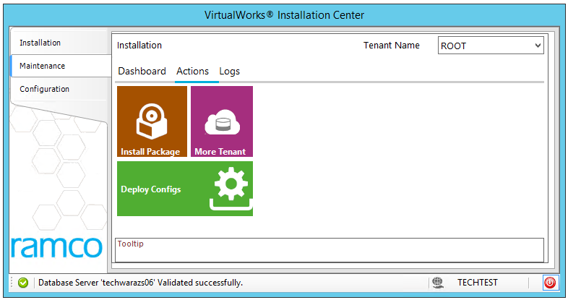

Click on INSTALL PACKAGE. Choose Rel_2.0.1.0.Zip Click on NEXT button.

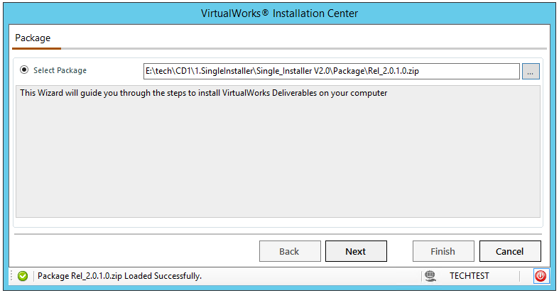

Summary page will appear. Click on INSTALL PACKAGE.

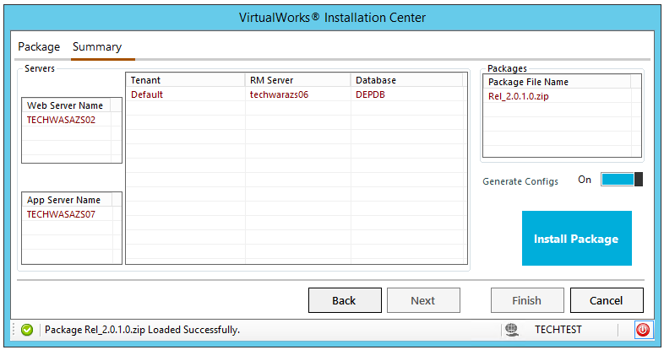

On successful completion, Installed Package successfully appears as shown below. You have successfully installed Runtime releases.

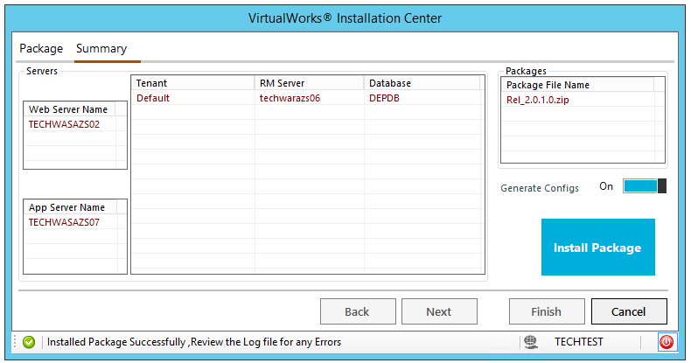

Click on CANCEL, which will take you to <#MaintenanceInstallation>. Continue with Install package for DecisionWorksSetup.zip, HRMS_1.0.0.0.zip. Follow the same steps.

Logs tab

