1. Prerequisite validataion error:

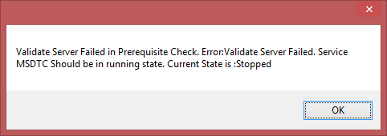

Solution: Check if Distributed Transaction Coordinator is running in the APP layer.

2) Error while login after new tenant installation (more tenant).

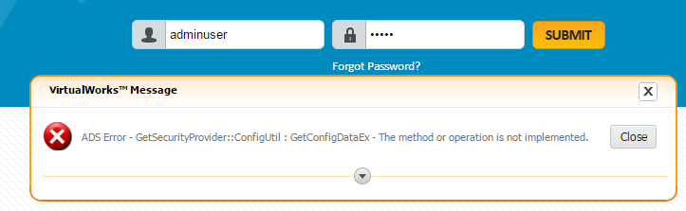

Solution : Kindly restart the service - Ramco.VW.RT.GatewayServerHost to refer the latest connectioninfo.config file.

1. Tenant names are not loaded in Tenant screen while logged in with valid root depdb.

Solution: Database name is different from root depdb name in fw_admin_rmsdepunit, kindly correct the same.

1. Microsoft.SqlServer.smo version mismatch error: You may need to install a Service Pack or Update to get a new version of the assembly ‘Microsoft.SqlServer.smo’

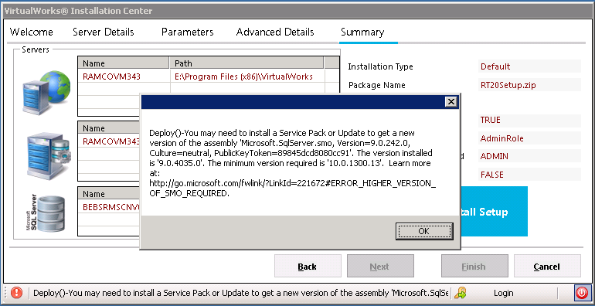

Solution: The proper Sql server version to be installed (or) run the exe from some other client/server machine.

1. Error on validate server: connected to ‘ramcovm343’ using the Web Deployment Agent Service, but could not authorize. – **while installation from different machine**.

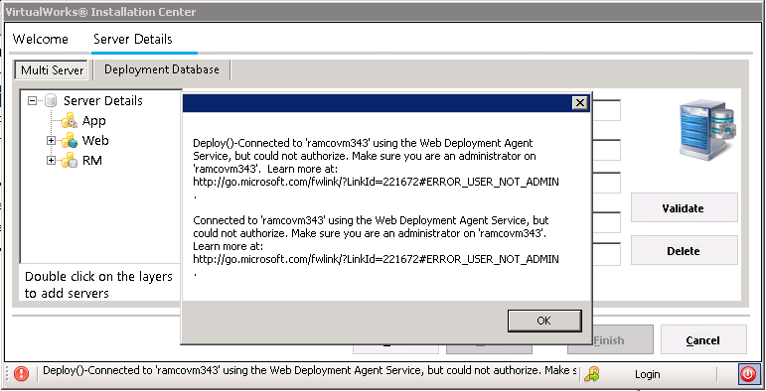

Solution: Kindly provide the Deploy user name and password then validate the server.

User name and password are required, if you are running the exe from the different machine.

6)System Role Has been changed, Kindly contact system administrator ~ MSDTC on server 'SP5103\SQLEXPRESS' is unavailable.

MSDTC service started in server.

1. After running the Single installer in existing environment getting the below error while launch of any activity.

Error Message : General Exception in CloseConnectionTODB - Connection opening failed : Login failed for user ''.

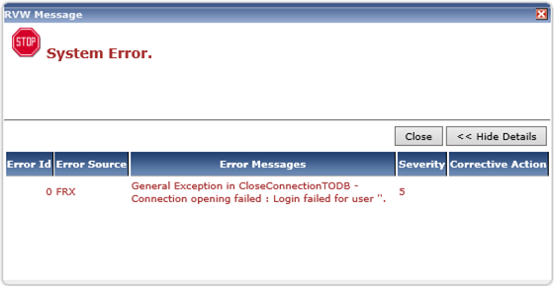

Solution: Single installer installed with different RM Server name( old: RMServer\InstanceName, new: RMServer), hence duplicate data in resource tables and invalid connection string in config files.

So kindly run the installer once again with proper RMServer name.

1. MS Web Deploy installation Error:

Soln: SSL Certificate enabled in IIS (inetmgr – Management service)

1. Install package error : invalid key error:

Soln: Server Names updated in installation center tables. (Changed from servername to local host)

1. Install package error: An item with the same key has already been added.

Error while running parallel process.

Soln: MS Web Deploy 3.5 uninstalled and install MS Web Deploy 3.6.