

Time Tracker

**VW Installation Center Steps**

28th March 2013

DISCLAIMER

**©2016 Ramco Systems Ltd. All rights reserved. All trademarks acknowledged.**

This document is published by **Ramco Systems Ltd**. without any warranty. No part of this document may be reproduced or transmitted in any form or by any means, electronic or mechanical, for any purpose without the written permission of **Ramco Systems Limited**.

Improvements and changes to this text necessitated by typographical errors, inaccuracies of current information or improvements to software programs and/or equipment, may be made by Ramco Systems Limited, at any time and without notice. Such changes will, however, be incorporated into new editions of this document. Any hard copies of this document are to be regarded as temporary reference copies only.

The documentation has been provided for the entire Aviation solution, although only a part of the entire solution may be deployed at the customer site, in accordance with the license agreement between the customer and Ramco Systems Limited. Therefore, the documentation made available to the customer may refer to features that are not present in the solution purchased / deployed at the customer site.

Contents

1. Introduction 3

2. Prerequisites 3

3. Steps for Installation 3

4. Multi -tenant Installation 4

4.1 Fresh / Ground up Installation 4

4.2 Existing Installation 9

# Introduction

VirtualWorks installation center will install VirtualWorks application.

# Prerequisites

* In case of https environment, create a self-signed certificate and then install web deploy 3.6 (<http://practical365.com/exchange-server/service-wmsvc-failed-to-reach-status-running-on-this-server> - use the steps indicated here)
* Web deploy 3.6 in Web, APP layers and in the File server from where the installation will be done.

Kindly choose installation type as complete and run the setup.

[http://subversion/svn/rvwmsdotnet/branches/ReleaseShare/Msrvw-DotNet-Installation/Utilities/Web Deploy v3.6](http://subversion/svn/rvwmsdotnet/branches/ReleaseShare/Msrvw-DotNet-Installation/Utilities/Web%20Deploy%20v3.6)

* Timeout settings in File server – Navigate to the following key in registry "HKEY_LOCAL_MACHINE\SOFTWARE\Microsoft\IIS Extensions\MSDeploy\3”. Create a new DWORD (32-bit) Value, set as DBCommandTimeout and give the decimal value as 300.
* In case of existing environment, please apply RT patch 20 and then apply this.

Kindly do consistency check and clear the scripts errors in existing depdb before run the single installer.

<http://subversion/svn/rvwmsdotnet/branches/ReleaseShare/Msrvw-DotNet-Installation/Utilities/ConsistencyCheck>

# Steps for Installation

Copy the folder VWInstallationCenter from the release path to the File server. Run the VWInstallationCenter.exe. The following screen will be popped up.

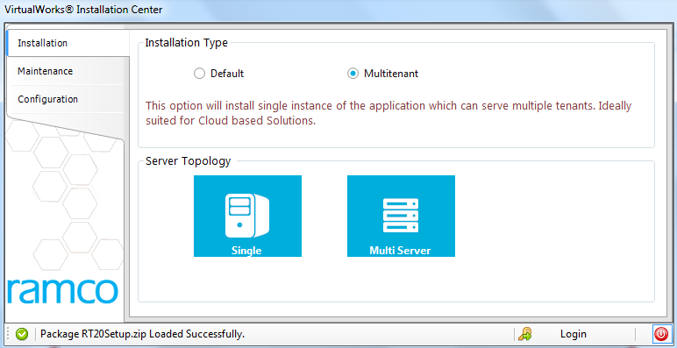

# Multi -tenant Installation

## 4.1 Fresh / Ground up Installation

🡪 Run the installer with either Single or Multi server setup as is the case be providing the web, app and Root RM details. (Refer InstallationSteps_defaults.docx from page No 4)

🡪 Now add the new Tenants using the following steps

Click on Maintenance

The following screen will appear. Connect to root deployment DB

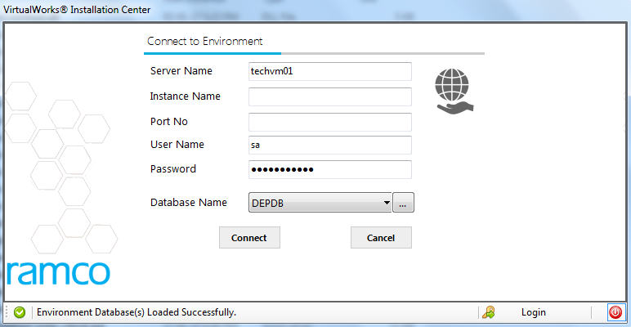

Click on CONNECT

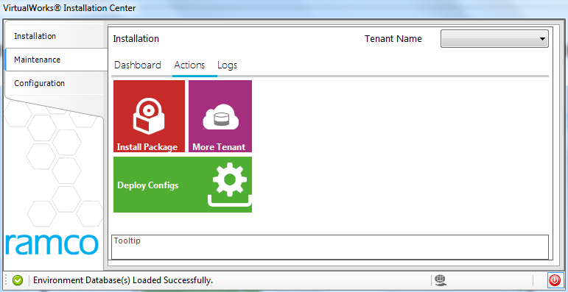

Click on More Tenant. The following screen is shown.

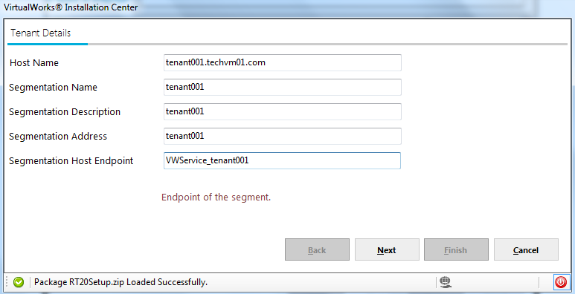

Host Name – This is the URL which will be used to launch this tenant.

Segmentation Name – A unique name for that tenant which will be the key.

Segmentation Description – Description for the tenant

Segmentation Address – This field is to be used later, please provide the same as description

Segmentation Hostendpoint – The end point URI for VWservice

Click on Next

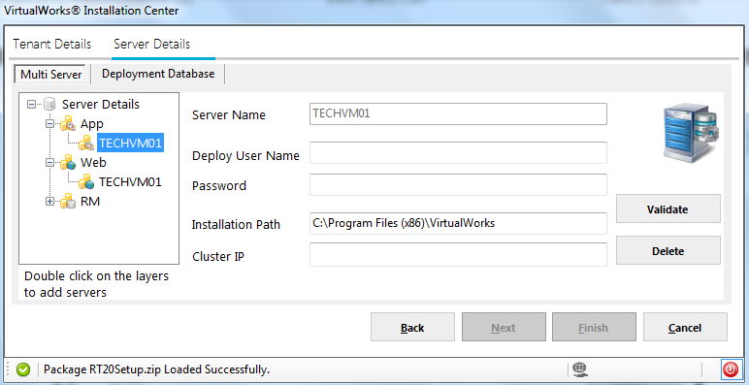

Entering the web/app server details will be disabled here, since the same has been done as part of Root Installation. For RM layer the server details has to be validated and only then NEXT button will be enabled.

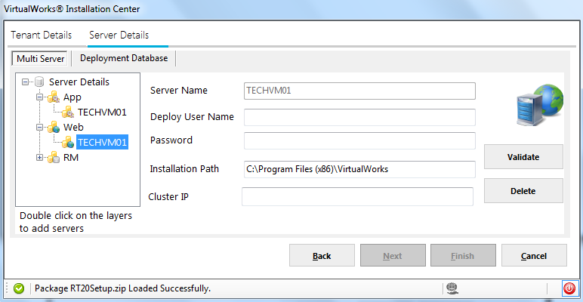

In this sequence only deployment database for the tenant will be captured as shown in the following screen.

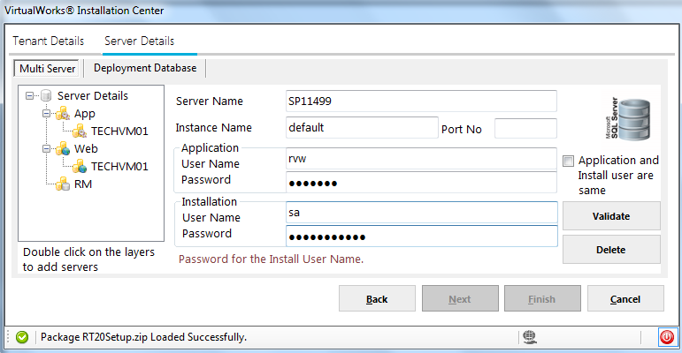

Click on Next, capture the Application and Deployment parameters.

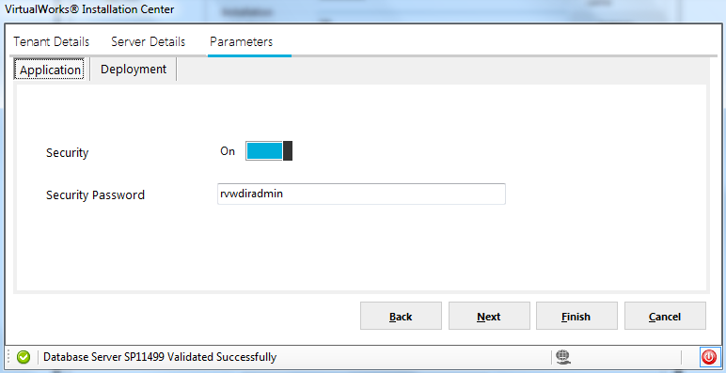

Click on Next

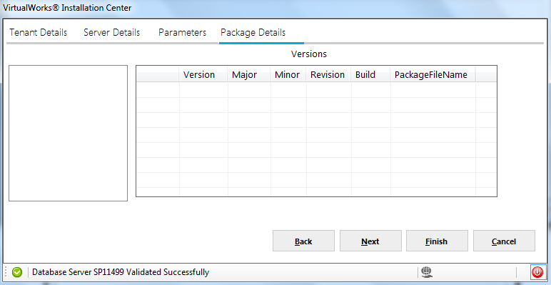

The above screen doesn’t have any details since this is a fresh multitenant setup. Click Next.

Advanced details will be shown.

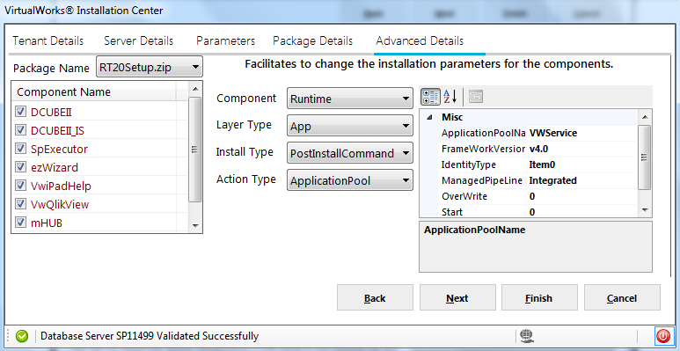

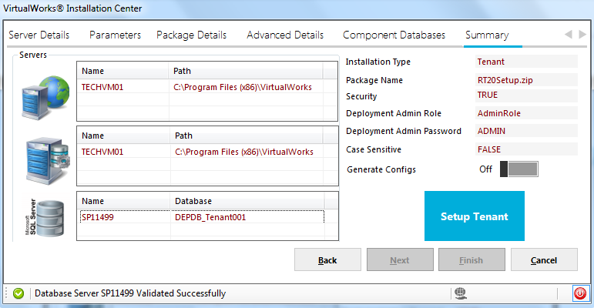

Click on setup Tenant .

The installation takes place in the following order

* Runtime and deployment components

DB layer and then the web and app layer. In case of error in DB layer, the installation rolls back for that component and hence web/app doesn’t get installed.

* Infra components

DB layer and then the web and app layer. In case of error in DB layer, the installation rolls back for that component and hence web/app doesn’t get installed. This set of components installation happens in parallel.

Once installation is completed succesfully, the tenant URL can be launched.

## 4.2 Existing Installation

🡪 Run the installer with either Single or Multi server setup as is the case may be providing the web, app and Root RM details. (Refer InstallationSteps_defaults.docx from page No 4)

🡪 Now add the new Tenants using the following steps

Click on Maintenance



Click on Install Package

Select the package to be deployed. Currently only one package is available.

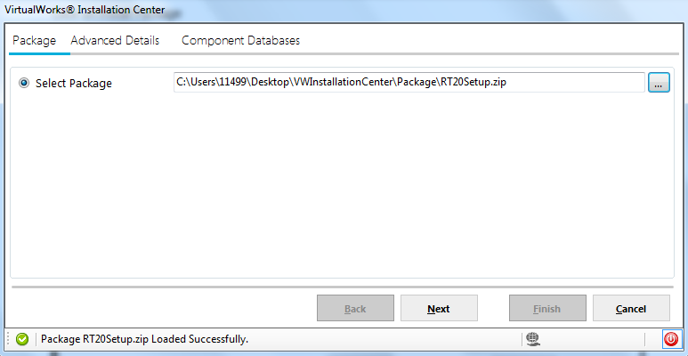

Click on Next

The list of tenants available in this setup is listed in the below screen.

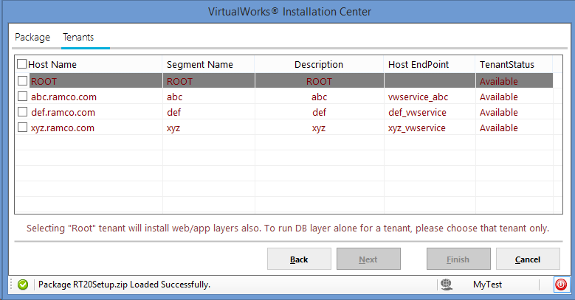

Click Next and then follow the same process for installation. In this Install package only DB layer will be run on all the tenants. In the Root installation, web and app layer will be completed.

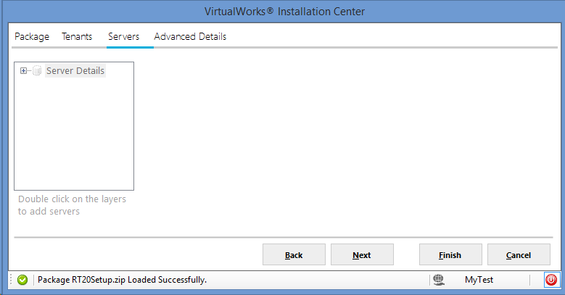

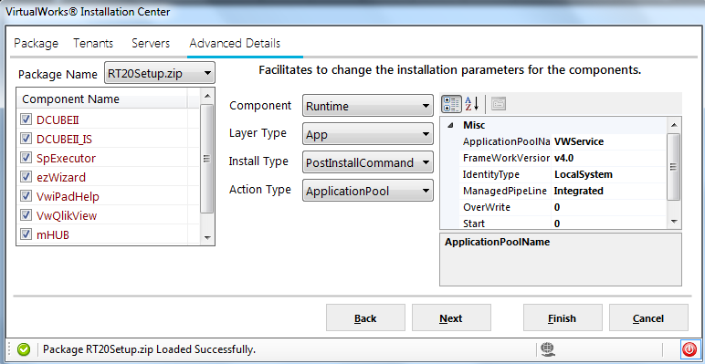

The summary of the components chosen for this tenant and their DB names will be listed. DB name can be changed for components other than Runtime (depadmin, deplocalization, security, vwrep_customization). Click on save if there are changes. Then click on Next.

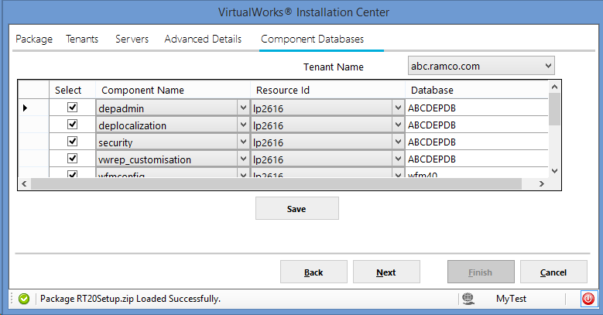

The summary of the installation which will be done is listed below. Click on Next

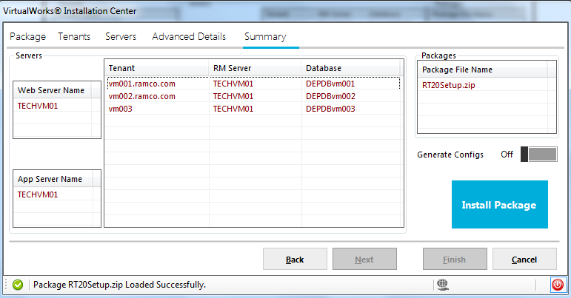

Click on Install package



The logs are available in the following path

C:\temp\VwInCe\Logs

*********************************** END of DOCUMENT ************************************************************