Windows 2012 R2 – Environmental Settings

©2008 Ramco Systems Ltd. All rights reserved. All trademarks acknowledged.

This document is published by Ramco Systems Ltd. without any warranty.

No part of this document may be reproduced or transmitted in any form or by any means, electronic or mechanical, for any purpose without the written permission of Ramco Systems Limited.

Improvements and changes to this text necessitated by typographical errors, inaccuracies of current information or improvements to software programs and/or equipment, may be made by Ramco Systems Limited, at any time and without notice. Such changes will, however, be incorporated into new editions of this document. Any hard copies of this document are to be regarded as temporary reference copies only.

Revision History
Version | Date | Author | Description
1.0 | 21/Dec/2012 | Karthik R | Created
2.0 | 09/Jul/2013 | Karthik R | Modified to add settings for Attach documents
3.0 | 26/07/2016 | Alice | Template changes

Contents

1.0 Settings to be done before starting Runtime Installation 4
1.0.1 Windows 2012 Settings 4
2.0 Settings to be done after completing Runtime Installation 10
2.0.1 Settings to be done in WEB Server 10
2.0.2 Settings to be done in APP Server 14
3.0 Enabling VirtualWorksTM Runtime specific ports in Firewall 15
4.0 Recommended Settings in WEB, APP and Database Servers 16
5.0 Recommendations for RVW .Net Environment 17

Environmental Settings for WIN 2012

1.0 Settings to be done before starting Runtime Installation

1.0.1 Windows 2012 Settings
- Go to Server Manager.

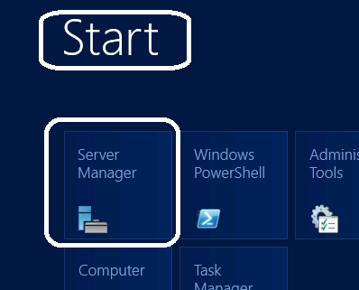

- Click on Add Roles and Features.

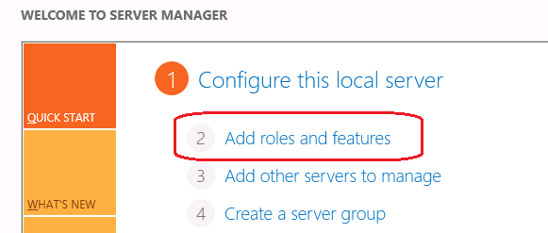

- On the installation type, select “Role-based or feature-based installation” and click on Next.
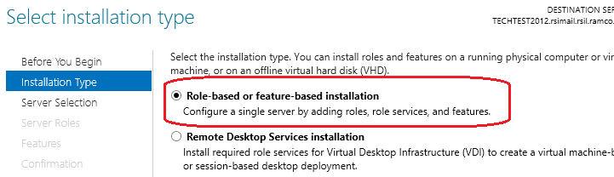

- Select the “Select a server from the server pool” option and select the current server name from the server pool.

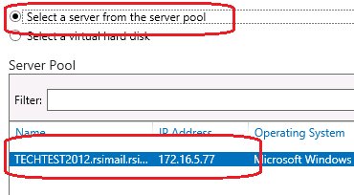

- Select the layer to be installed in the server. If WEB layer of VirtualWorksTM is to be installed, then select the WEB Layer and if APP layer of VirtualworksTM is to be installed, select the WEB and APP Layers. While selecting the WEB / APP layers, if the system by default prompts for some Role services/features to be installed, select the same and proceed further.

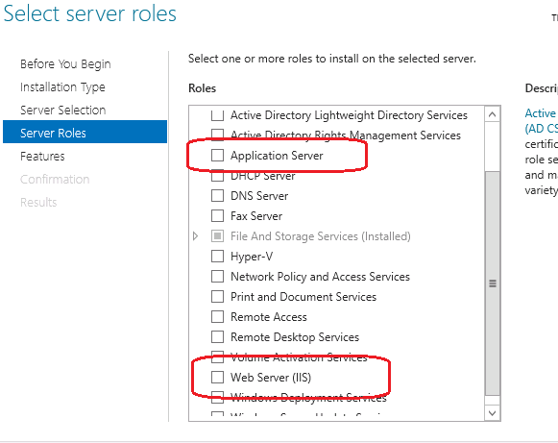

- On clicking Next, the features respective to the layers would be prompted. Select .Net Framework on all installing servers. (Make sure that the features HTTP Activation and Non-HTTP activation under “.Net Framework 3.5 features) are not selected. And make sure HTTP Activation, Named Pipe Activation, TCP Activation and TCP Port Sharing options are selected under WCF Services of .Net Framework 4.5 Features.

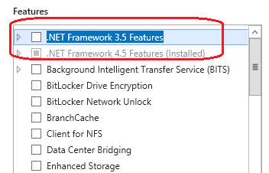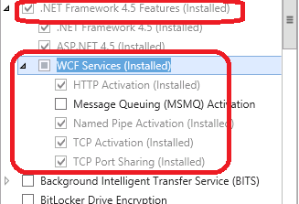

For Web Layer, select the following Role services:
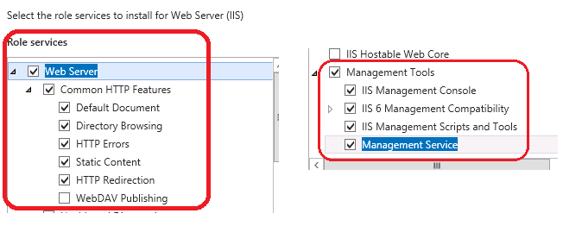

For App Server, select the following Role services:

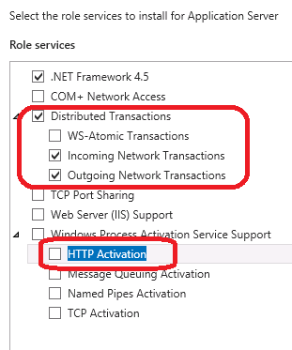
- Clicking Next, system will automatically display the selected Roles and Role Services to be installed in this server. Click on Install to install the same.

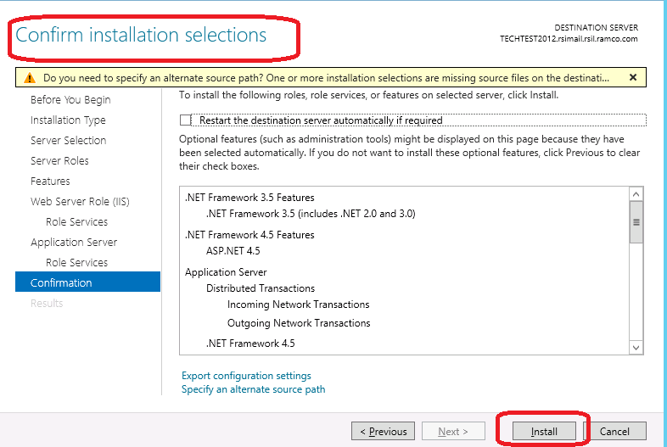

Wait for the installation to complete and restart the server if the same is prompted.

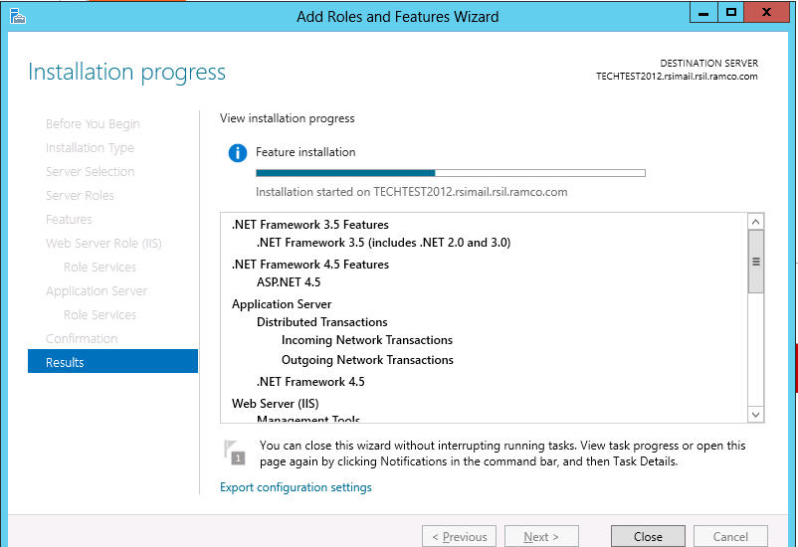

- Once the installation of the required Roles and Role Services are completed, select the System Properties -> Advanced System Settings -> Advanced Tab -> Environment Variables -> System Variables -> Edit the Path variable and paste the physical paths for .Net FW 3.5 and 2.0 in the same order as specified. This should be set in all participating servers (WEB, APP and DB/RM Server).

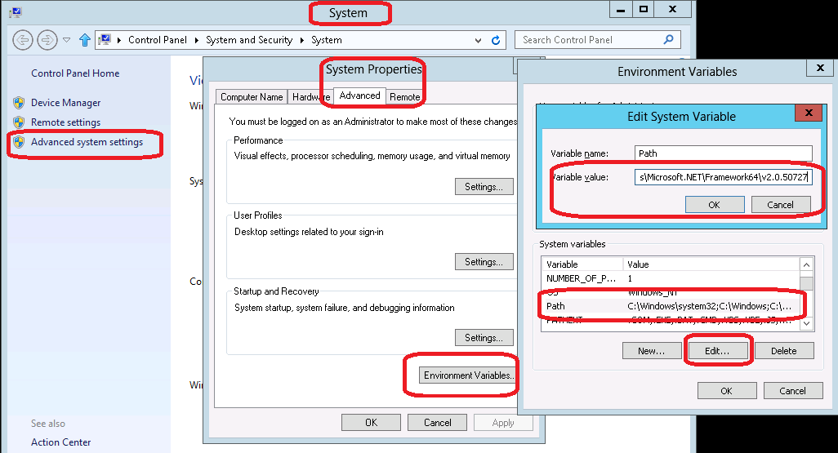

- If the Runtime installation is not done through the “Administrator” user account and is done through a user account with “Administrator” privileges (added in “Administrators” Group), then the following needs to be done. Please note that adding a user account to “Administrators” Group does not mean that the user has got “Administrator” equivalent privileges. So following privileges are required:

- User should be part of “Administrators” group
- User should be part of “Power Users” group
- The “User Account Control Settings” for the logged-in user account should be set to “Never Notify”. See image below for details:

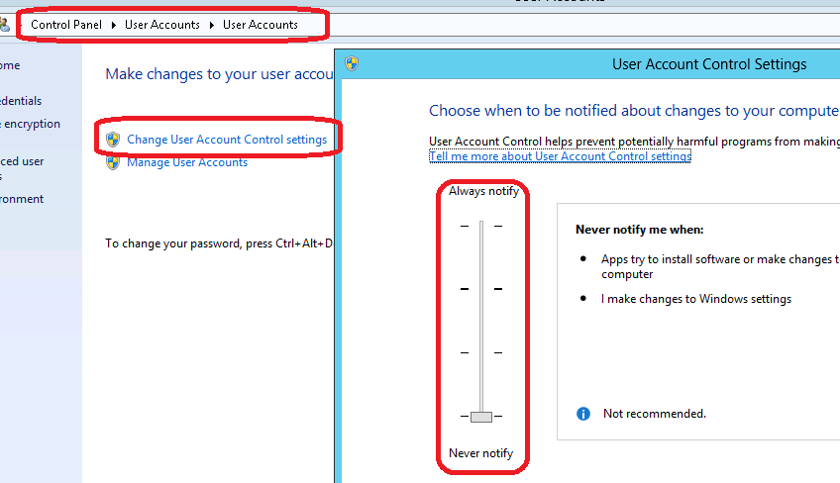

- Manually create a folder called “Preferences” under .\Program Files (x86) folder and provide “Full Control” (under Security Tab) for the logged-in user account. See image below for details.

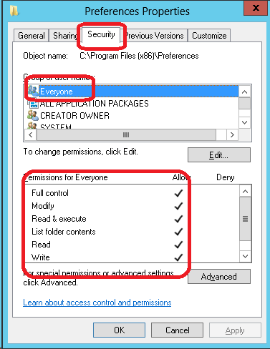

- Do the settings as given below. These settings should also be done on all participating layers (WEB, APP and DB).
- Run gpedit.msc from Run, navigate and browse to Computer Configuration -> Windows Settings -> Security Settings -> Local Policies -> Security Options
- Set policy User Account Control: Behavior of the elevation prompt for administrators to – Elevate without prompting
- Set policy User Account Control: Detect application installations and prompt for elevation to – Disabled
- Set policy User Account Control: Run all administrators in Admin Approval Mode to – Disabled

- After completing the above steps, restart the system (settings to be set in all layer machines where the installation would be done) and follow the base and RT Patch installation documents. While running the RSSetup.exe from the Base Runtime installation kit, VirtualWorks folder would get created under ..\Program Files (x86) folder. User should have “Full Control” privileges for VirtualWorks and its sub-folders (under Security Tab). This permission should be given before running the RuntimeSetup.MSI.

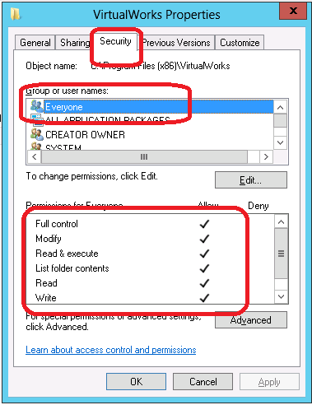

2.0 Settings to be done after completing Runtime Installation

2.0.1 Settings to be done in WEB Server
2.0.1.1 Creating Application Pool

- Open Internet Information Services (IIS) (Start -> Run -> Inetmgr)

- Select Application Pools and right click and click on Add Application Pool. Create a new Application pool by name RVW (provide the details as per the attached image). Click on OK.
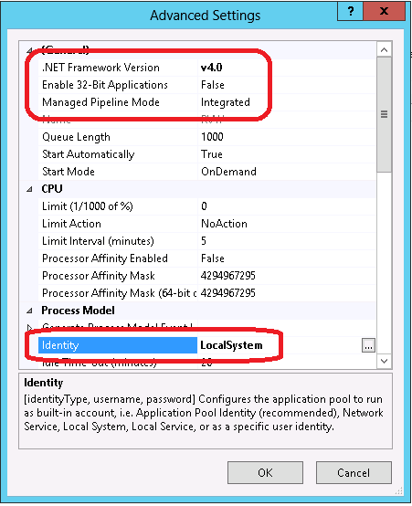

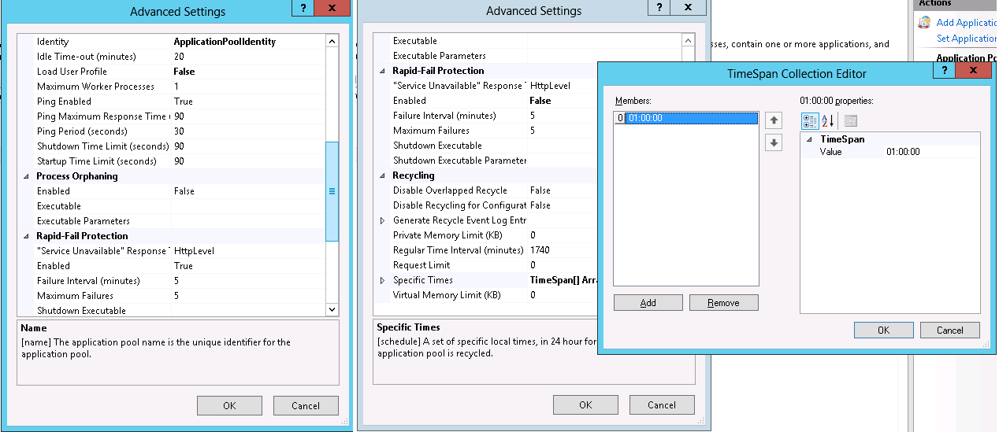

- Click on Specific Times and select the TimeSpan[] Array. In the new window that opens up, click on Add and change the value on the right side to 01:00:00 (01.00 AM). This means that the IIS worker process will be restarted at 1 AM every day. This can be changed as per the customer’s requirement.

2.0.1.2 Creating RVW Virtual directory

On certain occasions the RVW Virtual Directory will not get created automatically by the installer. Follow the steps given below to create the virtual directory manually.

- Open IIS (Go to Start -> Run -> Type INETMGR and click on OK)

- Explore till Default Web Site under the Server name and Right Click on the Default Web Site and Click on "Add Application…".

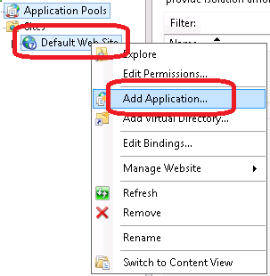

- On the window that gets opened, provide the details as given and click OK:

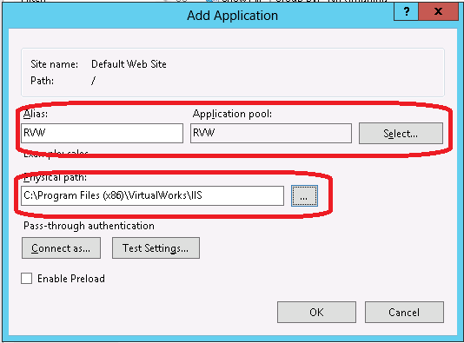

- In the above image, the Physical path should be changed to the IIS folder where VirtualWorksTM application is installed and the Application pool should be set to RVW which was defined under 2.0.1.1.

- Click on RVW Virtual Directory and select the Default Document option on the right pane and open the same.

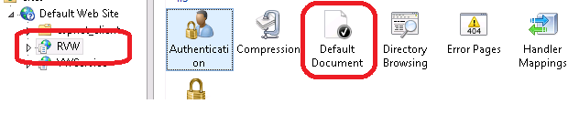

- In the options that get listed, select all the existing documents and delete and then right click and click on Add and add the default document as RVW_Default.ASPX.

- Increase the value of “timeout” from 20 minutes to 60 minutes in WEB.Config file under ..\VirtualWorks\IIS folder.
…
…
…
<customErrors mode="RemoteOnly" />
<trace enabled="false" pageOutput="false" />
<sessionState mode="InProc" cookieless="false" timeout="60" />
…
…
…
2.0.1.3 Setting permissions for User Personalization to work

When the application user tries to personalize the multiline for altering the sequence of the columns or to increase/decrease size of the columns or to change the column headers, he will use the Personalization feature to do the same. While doing so, if the ..\VirtualWorks\IIS\Preferences (for DNA Version, ..\Active Marshal\IIS\Preferences) folder does not have write privileges, then Access to the path <…> is denied error will be thrown. To avoid this, follow the settings as given below. By enabling this, there is absolutely no security breach as this setting would only enable Full Control privilege for the IIS process to write to the respective folder and not open a share that would be exposed to all the users on the network.

- Go to Explorer and open the properties window for the folder ..\IIS\Preferences.
- Go to Security tab and click on the Edit button. (Edit button may not be available on Windows 2003 server in which case, proceed to the next step)
- Check if the user account “Everyone” is listed. If not, add the same using the Add button.
- If the user account “Everyone” is listed, select that user account and click on Full Control check box from the bottom pane and click on Apply.

Note: On a non-Single Sign-On based environment, it is sufficient to provide these privileges only for IUSR and IWAM user accounts and not required to be set at “Everyone” user account level.

2.0.1.4 Cookieless Settings

There are certain pros and cons while setting Cookieless to True or False. Go through the table below and understand the impact of enabling or disabling the need and also after understanding the requirement of the customer, make changes to the setting. This setting would be available in WEB.Config file under ..\VirtualWorks\IIS folder. By default, this setting would be set to “false”. If this needs to be enabled, set this setting to “true” (case-sensitive).

…
…
<customErrors mode="RemoteOnly" />
<trace enabled="false" pageOutput="false" />
<sessionState mode="InProc" cookieless="false" timeout="20" />
<httpRuntime executionTimeout="180" />
</system.web>
…
…
Differences of setting Cookieless to
True | False
HTM Version: New Window functionality available in CommonActions toolbar will work. | New window feature will not work.
User would be able to work in the application by opening the application URL across multiple browser windows / multiple tabs. | At any given point of time, user can work only from one single window. If the user wants to open the application URL in another window, he has to either use “IEXPLORE –NOMERGE” option from Run or from an already launched IE window, use File->New Session and then launch the URL on that new opened window.
There will be a huge performance impact as static files will not be cached across sessions. So every time user opens the application, all static files would be downloaded from the server. | Provides better performance as static files would be cached across multiple sessions until IE Cache is cleared manually / automatically.
Does not support Report Isolation | Supports Report Isolation.

2.0.1.5 Settings for Attach Documents to work with SSL enabled sites

This portion of the document is valid only for .Net based VirtualWorksTM installation running with SSL.

Observation:
Actual Error: “The page was not displayed because the request entity is too large”

The problem occurs if the server is using Secure Sockets Layer (SSL) and user is trying to upload a file which is more than the default size allowed by IIS

Root Cause:
In order for IIS uses a new metabase property called UploadReadAheadSize when passing data to an ISAPI extension. In this particular case the customer was using CAC (client access certs) and so the SSL preload was using this property to determine the maximum buffer size for the incoming request. The default size for this buffer is 48k, which was added to prevent anonymous DOS attacks by uploading very large garbage files

When we check for the UploadReadAheadSize in the server where the issue occurs the following results has come, the UploadReadAheadSize value was not set.
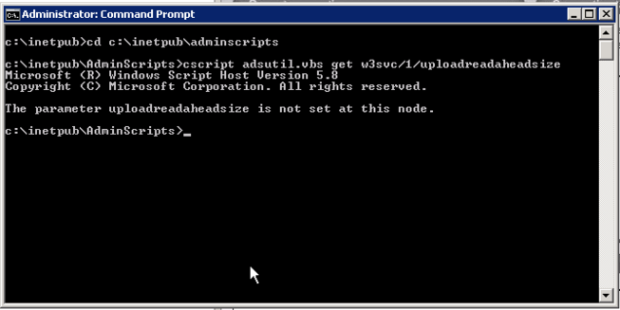
Solution:

To solve this issue simply increase the size of the Web Server IIS metabase property UploadReadAheadSize to some size as per the requirement, say for example if we want to increase the size to 100MB the following command to be executed from the path “C:\inetpub\adminscripts”.

cscript adsutil.vbs set w3svc/1/uploadreadaheadsize 104857600

The metabase setting is represented in bytes, we can set upto 4GB
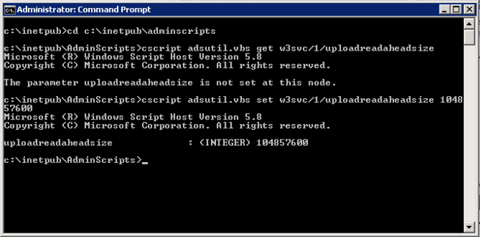

2.0.2 Settings to be done in APP Server
Following steps should be changed in Com+ Explorer. Please make sure that these points (1, 2, 4 and 5) are done in Database Layer machine also. If “APP Server” role is not available in Database layer machine, add the same and do these settings.

- Open COM+ Explorer

- Expand to “My Computer” node and go to the properties of “My Computer”

- Expand Distributed Transactions -> Select Local DTC and click on properties and click on Security tab and choose the options as per the image below

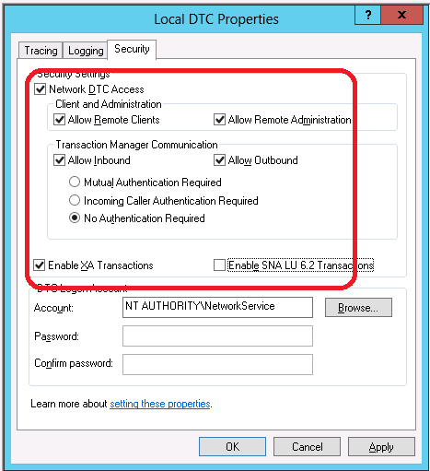

- Choose Logging tab and change the Capacity to 40 MB. Click on OK.

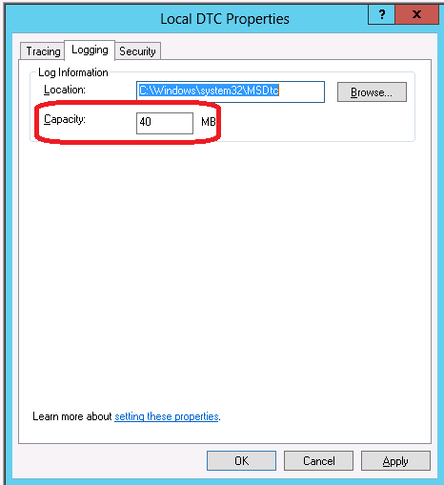

3.0 Enabling VirtualWorksTM Runtime specific ports in Firewall

In case the customer wants to have firewall between WEB/APP/Database layers, the following ports should be opened Bi-Directionally in the Firewall between the immediate source and the destination servers.

For VirtualWorksTM .Net Runtime, following ports are mandatory:

Service Name | Port No. | Direction
Internet Information Services (IIS) | Default Port 80 (If this is changed in IIS, then the modified port should be enabled in Firewall) | Bi-Directional – Between WEB and APP Servers.
VWSocketServer | Whichever port is specified while generating WEBConfig and APPConfig DLLs through ConfigGenerator | Bi-Directional – Between WEB and APP Servers.
Ramco Daemon Service (proprietary to VirtualWorksTM) | Default Port 1306 (Configurable through RDE Configuration) | Bi-Directional – Between the server on which Daemon Engine is configured and Database Server.
MS SQL Server | Default Port 1433, 1434 (Can be changed at the time of installation of MS SQL Server) | Bi-Directional – Between APP and Database Server.
MSDTC | This service uses 135 as a mandatory port and also another port for communication between APP and RM Layer. The second port is dynamic and can vary between the entire allowable TCP port ranges. This port range can be restricted manually through COM. Contact Runtime Support team on how to configure manual port ranges. | Bi-Directional – Between APP and Database Server.
Net.TCP, Net.Pipe  (Services running on APP Server) | Ports – 807 and 808 (This is required only if Communicator Type is set to 1 in WEB.Config file in WEB Server under ..\VirtualWorks\IIS). | Bi-Directional – Between WEB and APP Servers.

4.0 Recommended Settings in WEB, APP and Database Servers

Note: Server name (across all layers) should not have any special characters. All server names participating in the VirtualWorksTM deployment architecture should start with alphabets and can contain numbers. Non-Alphanumeric characters are not allowed. Servers should also not have any VirtualWorksTM component name and part of the Server Name.

4.1 Entries in LMHOSTS and HOSTS file

- Add the IP address of the APP Server in LMHosts file of the WEB Server (in case WEB and APP servers are two different physical machines)
  - Open the LMHOSTS (without extension) file available under %systemroot%\SYSTEM32\Drivers\ETC folder and go to the end of the file.
  - Add a new line and type the IP address (of the App server name) and the App server machine name separated by the tab space and save the file.

- Add the WEB Server IP and the Application Server IP Address in the HOSTS File
- Open the HOSTS (without extension) file available under %systemroot%\SYSTEM32\Drivers\ETC folder and go to the end of the file.
- Add a new line and specify the IP Address of the WEB and the Application Server and its machine name separated by Tab space. Save the file and close it.

- Add the IP address of the WEB Server and RM Server in LMHosts file of the APP Server
- Open the LMHOSTS (without extension) file available under %systemroot%\SYSTEM32\Drivers\ETC folder and go to the end of the file.
- Add a new line and type the IP address (of the WEB server name and the RM Server) and the WEB and RM server machine names separated by the tab space and save the file.

- Add the WEB Server IP, Application Server IP and the RM Server IP Addresses in the HOSTS File
- Open the HOSTS (without extension) file available under %systemroot%\SYSTEM32\Drivers\ETC folder and go to the end of the file.
- Add a new line and specify the IP Address of the WEB, Application and the RM Server and its machine name separated by Tab space. Save the file and close it.

- Add the IP address of the Application Server in LMHosts file of the RM Server
- Open the LMHOSTS (without extension) file available under %systemroot%\SYSTEM32\Drivers\ETC folder and go to the end of the file.
- Add a new line and type the IP address of the App server name and the Application server machine names separated by the tab space, save the file and close it.

- Add the Application Server IP and the RM Server IP Addresses in the HOSTS File
- Open the HOSTS (without extension) file available under %systemroot%\SYSTEM32\Drivers\ETC folder and go to the end of the file.
- Add a new line and specify the IP Address of the Application and RM Server and its machine name separated by Tab space. Save the file and close it.

Once all the above settings are completed, restart the WEB, Application and the RM Server. Make sure all the necessary services are restarted.

5.0 Recommendations for RVW .Net Environment

- Write/Modify/Delete/Full Control shares should not be given to VirtualWorks folder and subfolders in WEB server.

- Any modifications to VirutalWorks folder has to be done only by system administrator.

- Any modifications to the VirtualWorks folder should be taken up only during system maintenance periods and should be done only after stopping IIS, RamcoGatewayServerhost and VWServerSocket services.

- More than one virtual directory pointing to IIS folder may cause the respective application pools to recycle. Make sure there is only one virtual directory pointing to IIS folder. Also do not create multiple virtual directories for any of the sub-folders inside IIS.

- Addition/deletion/modification of any files in VirtualWorks\IIS folder will lead to App pool recycling and the users would face Session expired issues and will be forced to re-login into the application.

- Make sure no other applications / FTP uploads write / modify / delete any files / contents into the VirtualWorks\IIS folder as this would also recycle the application pool.

- Do not create unnecessary copies of Runtime deliverables as it could tamper the environment and make it difficult to resolve issues at critical situations. If any backup of deliverables have to be taken, move them to separate backup folders outside the VirtualWorks folder.

- Do not modify the entries in the deployment tables created by the installer. Every entry is these deployment tables have a purpose and any modification to these entries would create huge impacts which can not be rolled back.

- Any issues faced in the application, please contact the Runtime support team. It would be easy for us to resolve the issues being reported at the initial stages. Also please make a note of the steps that led to the problem. This would help us in resolving the issue much faster.

- End of Document -

Corporate Office and R&D Center
Ramco Systems Limited, 64, Sardar Patel Road, Taramani Chennai – 600 113, India
Tel: +91 (44) 2235 4510. Fax +91 (44) 2235 2884
www.ramco.com

