Windows 2012 R2 – Environmental Settings

©2008 Ramco Systems Ltd. All rights reserved. All trademarks acknowledged.

This document is published by Ramco Systems Ltd. without any warranty.

No part of this document may be reproduced or transmitted in any form or by any means, electronic or mechanical, for any purpose without the written permission of Ramco Systems Limited.

Improvements and changes to this text necessitated by typographical errors, inaccuracies of current information or improvements to software programs and/or equipment, may be made by Ramco Systems Limited, at any time and without notice. Such changes will, however, be incorporated into new editions of this document. Any hard copies of this document are to be regarded as temporary reference copies only.

Revision History
Version | Date | Author | Description
1.0 | 21/Dec/2012 | Karthik R | Created
2.0 | 09/Jul/2013 | Karthik R | Modified to add settings for Attach documents
3.0 | 26/07/2016 | Alice | Template changes

Contents

1.0 Settings to be done before starting Runtime Installation 4
1.0.1 Windows 2012 Settings 4
2.0.2 Settings to be done in APP Server 10
3.0 Enabling VirtualWorksTM Runtime specific ports in Firewall 12

Environmental Settings for WIN 2012

1.0 Settings to be done before starting Runtime Installation

1.0.1 Windows 2012 Settings
- Go to Server Manager.

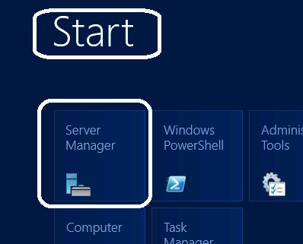

- Click on Add Roles and Features.

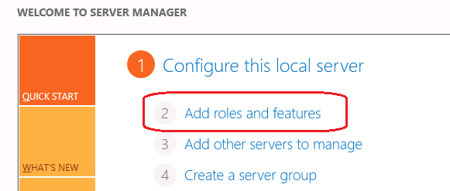

- On the installation type, select “Role-based or feature-based installation” and click on Next.
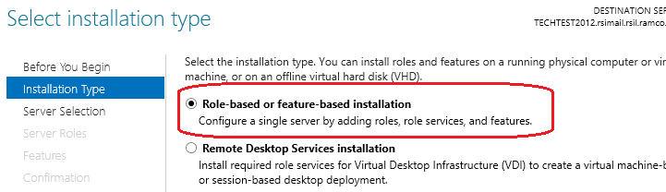

- Select the “Select a server from the server pool” option and select the current server name from the server pool.

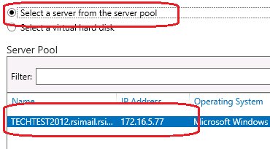

- Select the layer to be installed in the server. If WEB layer of VirtualWorksTM is to be installed, then select the WEB Layer and if APP layer of VirtualworksTM is to be installed, select the WEB and APP Layers. While selecting the WEB / APP layers, if the system by default prompts for some Role services/features to be installed, select the same and proceed further.

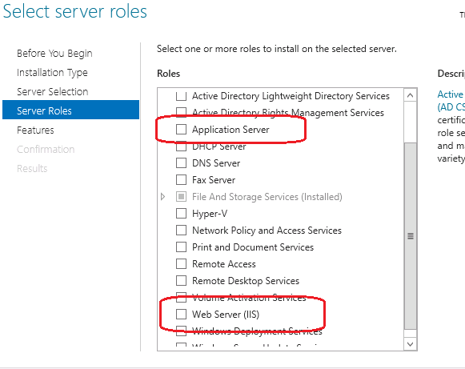

- On clicking Next, the features respective to the layers would be prompted. Select .Net Framework on all installing servers. (Make sure that the features HTTP Activation and Non-HTTP activation under “.Net Framework 3.5 features) are not selected. And make sure HTTP Activation, Named Pipe Activation, TCP Activation and TCP Port Sharing options are selected under WCF Services of .Net Framework 4.5 Features.

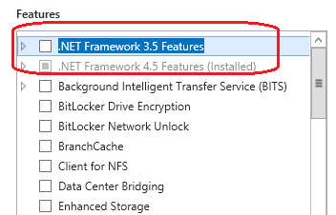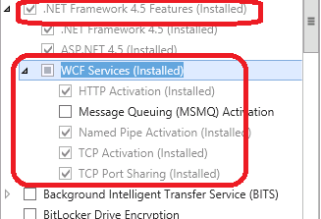

For Web Layer, select the following Role services:
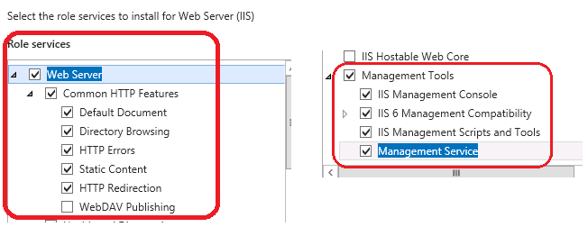

For App Server, select the following Role services:

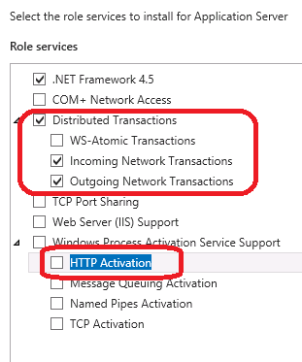
- Clicking Next, system will automatically display the selected Roles and Role Services to be installed in this server. Click on Install to install the same.

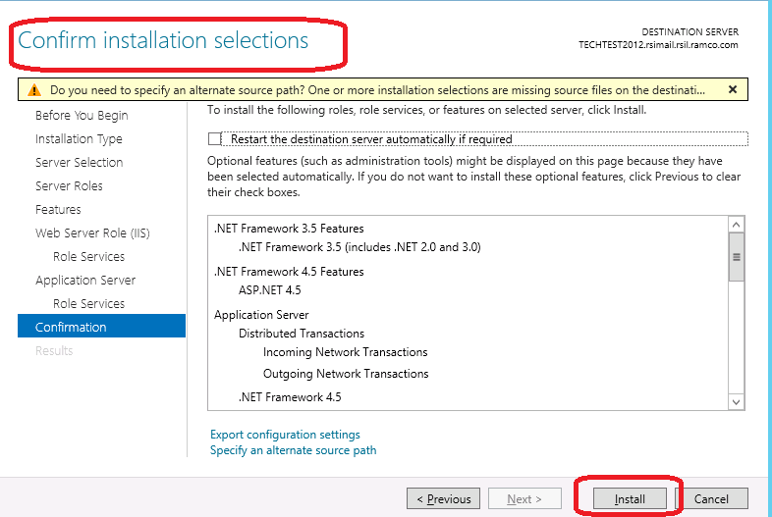

Wait for the installation to complete and restart the server if the same is prompted.

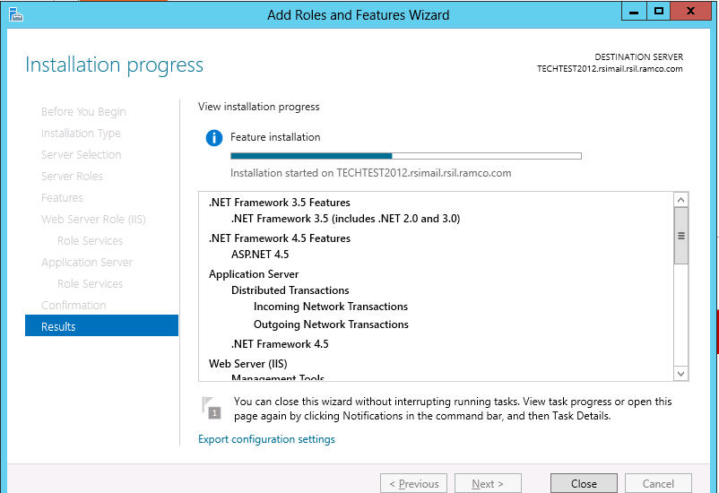

- Once the installation of the required Roles and Role Services are completed, select the System Properties -> Advanced System Settings -> Advanced Tab -> Environment Variables -> System Variables -> Edit the Path variable and paste the physical paths for .Net FW 3.5 and 2.0 in the same order as specified. This should be set in all participating servers (WEB, APP and DB/RM Server).

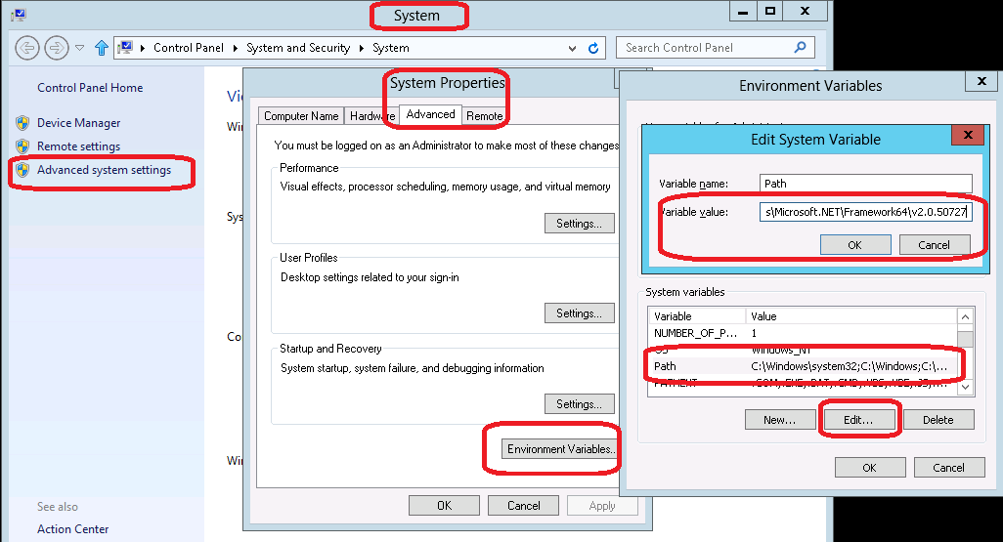

- If the Runtime installation is not done through the “Administrator” user account and is done through a user account with “Administrator” privileges (added in “Administrators” Group), then the following needs to be done. Please note that adding a user account to “Administrators” Group does not mean that the user has got “Administrator” equivalent privileges. So following privileges are required:

- User should be part of “Administrators” group
- User should be part of “Power Users” group
- The “User Account Control Settings” for the logged-in user account should be set to “Never Notify”. See image below for details:

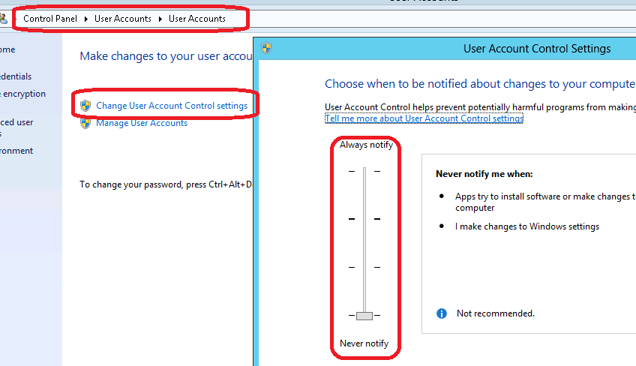

- Manually create a folder called “Preferences” under .\Program Files (x86) folder and provide “Full Control” (under Security Tab) for the logged-in user account. See image below for details.

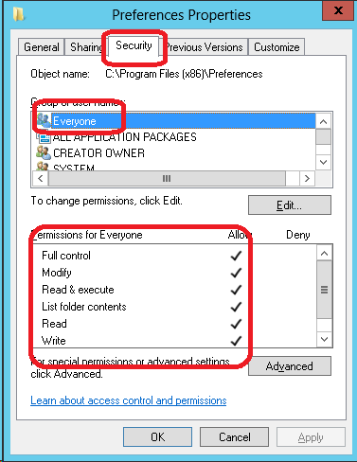

- Do the settings as given below. These settings should also be done on all participating layers (WEB, APP and DB).
- Run gpedit.msc from Run, navigate and browse to Computer Configuration -> Windows Settings -> Security Settings -> Local Policies -> Security Options
- Set policy User Account Control: Behavior of the elevation prompt for administrators to – Elevate without prompting
- Set policy User Account Control: Detect application installations and prompt for elevation to – Disabled
- Set policy User Account Control: Run all administrators in Admin Approval Mode to – Disabled

- After completing the above steps, restart the system (settings to be set in all layer machines where the installation would be done) and follow the base and RT Patch installation documents. While running the RSSetup.exe from the Base Runtime installation kit, VirtualWorks folder would get created under ..\Program Files (x86) folder. User should have “Full Control” privileges for VirtualWorks and its sub-folders (under Security Tab). This permission should be given before running the RuntimeSetup.MSI.

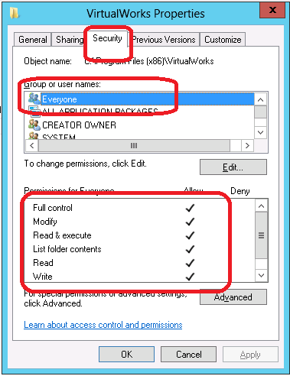

2.0.2 Settings to be done in APP Server
Following steps should be changed in Com+ Explorer. Please make sure that these points (1, 2, 4 and 5) are done in Database Layer machine also. If “APP Server” role is not available in Database layer machine, add the same and do these settings.

- Open COM+ Explorer

- Expand to “My Computer” node and go to the properties of “My Computer”

- Expand Distributed Transactions -> Select Local DTC and click on properties and click on Security tab and choose the options as per the image below

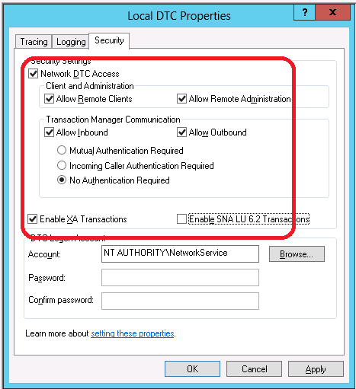

- Choose Logging tab and change the Capacity to 40 MB. Click on OK.

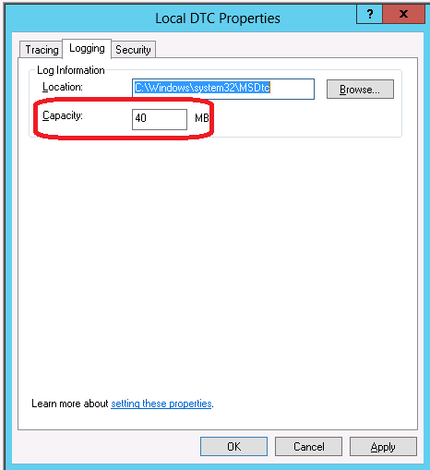

3.0 Enabling VirtualWorksTM Runtime specific ports in Firewall

In case the customer wants to have firewall between WEB/APP/Database layers, the following ports should be opened Bi-Directionally in the Firewall between the immediate source and the destination servers.

For VirtualWorksTM .Net Runtime, following ports are mandatory:

Service Name | Port No. | Direction
Internet Information Services (IIS) | Default Port 80 (If this is changed in IIS, then the modified port should be enabled in Firewall) | Bi-Directional – Between WEB and APP Servers.
Ramco Daemon Service (proprietary to VirtualWorksTM) | Default Port 1306 (Configurable through RDE Configuration) | Bi-Directional – Between the server on which Daemon Engine is configured and Database Server.
MS SQL Server | Default Port 1433, 1434 (Can be changed at the time of installation of MS SQL Server) | Bi-Directional – Between APP and Database Server.
MSDTC | This service uses 135 as a mandatory port and also another port for communication between APP and RM Layer. The second port is dynamic and can vary between the entire allowable TCP port ranges. This port range can be restricted manually through COM. Contact Runtime Support team on how to configure manual port ranges. | Bi-Directional – Between APP and Database Server.
Net.TCP, Net.Pipe  (Services running on APP Server) | Ports – 807 and 808 (This is required only if Communicator Type is set to 1 in WEB.Config file in WEB Server under ..\VirtualWorks\IIS). | Bi-Directional – Between WEB and APP Servers.

- End of Document -
Corporate Office and R&D Center
Ramco Systems Limited, 64, Sardar Patel Road, Taramani Chennai – 600 113, India
Tel: +91 (44) 2235 4510. Fax +91 (44) 2235 2884
www.ramco.com

